HDOC DAY-7 REPORT

Question 1: Angular Displacement

Problem Statement:
Write a C program to find angular displacement when angular velocity and time are given.
Input:
1. Angular velocity (ω) in rad/s
2. Time (t) in seconds

Output:
Angular displacement (θ) in radians

Formula:
θ = ω × t
Test case | Angular Velocity(ω) | Time(t) | Expected Angular  Displacement(θ)
1 | 5rad/s | 2s | 10rad
2 | 10rad/s | 3s | 30rad
3 | 2.5rad/s | 4s | 10rad

Algorithm:
- Start the program.
- Enter the angular velocity (ω).
- Enter the time (t).
- Calculate angular displacement using the formula θ = ω × t.
- Display the angular displacement (θ).
- Stop the program.

#include <stdio.h>

int main()
{
float angular_velocity, time, angular_displacement;

printf("Enter angular velocity (rad/s): ");
scanf("%f", &angular_velocity);

printf("Enter time (s): ");
scanf("%f", &time);

angular_displacement = angular_velocity * time;

printf("Angular displacement = %.2f rad\n", angular_displacement);

return 0;
}
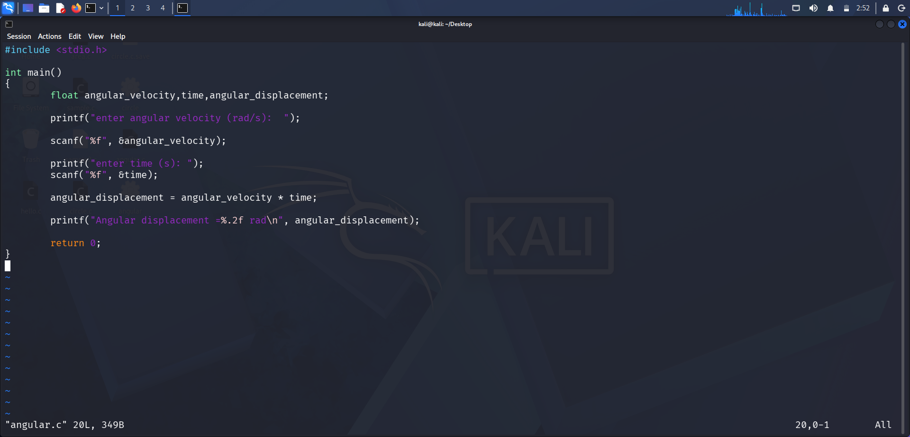



Execution / Output:
The program was successfully compiled and executed in Kali Linux.
Input:
Angular Velocity = 5 rad/s
Time = 2 s
Output:
Angular Displacement = 10.00 rad

Question 2: Electric Power
Problem Statement:
gram to calculate electric power when voltage and current are given.
Input:
- Voltage (V) in volts
- Current (I) in amperes
Output:
Electric power (P) in watts
Formula:
P = V × I
Tast Case Table
Test Case | Voltage (V) | Current (I) | Expected Power (P)
1 | 10V | 2A | 20W
2 | 20V | 3A | 60W
3 | 12V | 5A | 60W

Algorithm:
- Start the program.
- Enter the voltage (V).
- Enter the current (I).
- Calculate electric power using the formula P = V × I.
- Display the electric power (P).
- Stop the program.

#include <stdio.h>

int main()
{
float voltage, current, power;

printf("Enter voltage (V): ");
scanf("%f", &voltage);

printf("Enter current (A): ");
scanf("%f", &current);

power = voltage * current;

printf("Electric Power = %.2f W\n", power);

return 0;
}
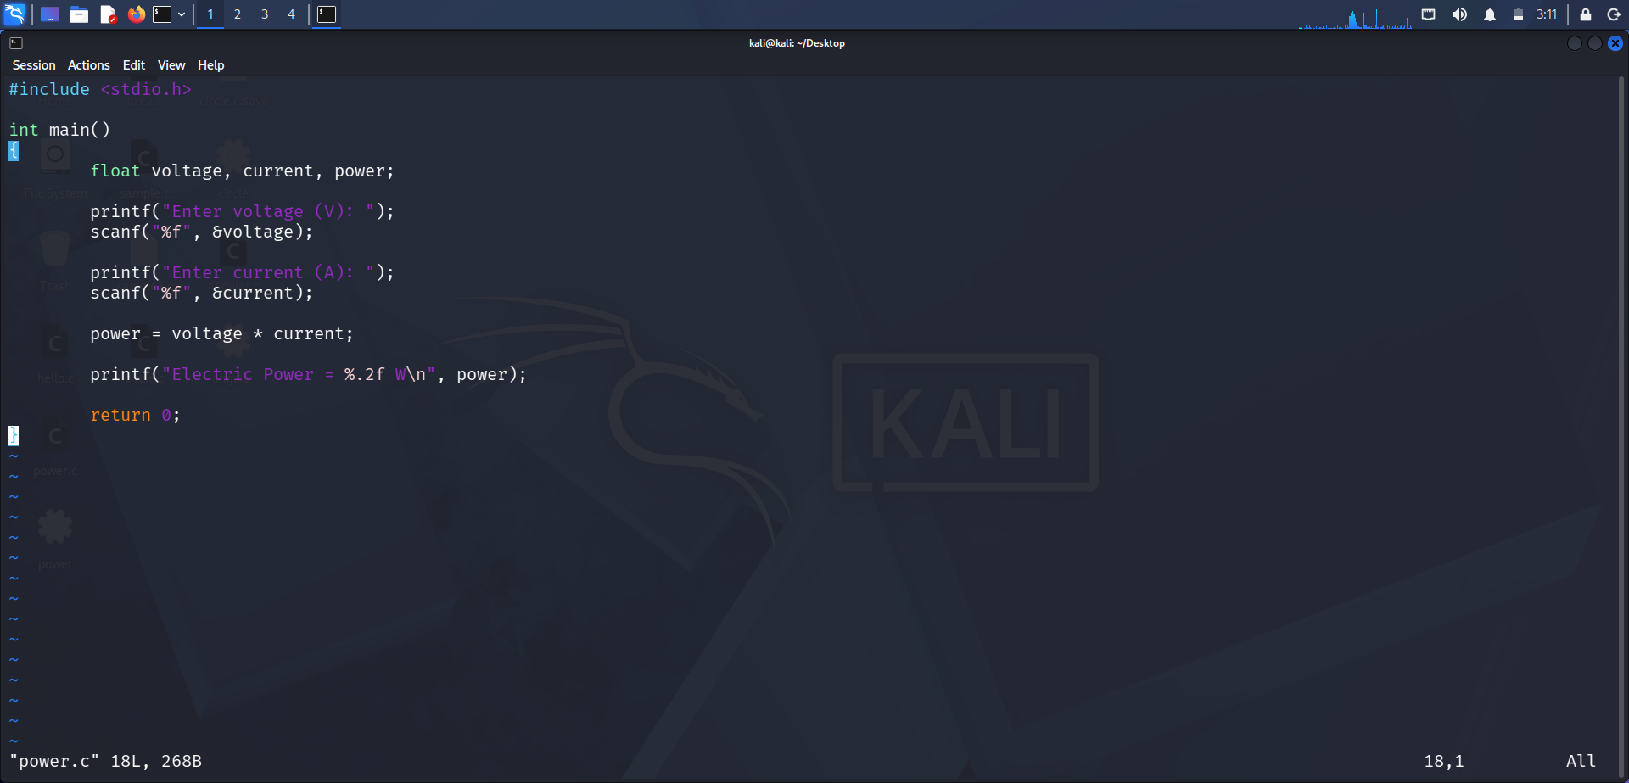

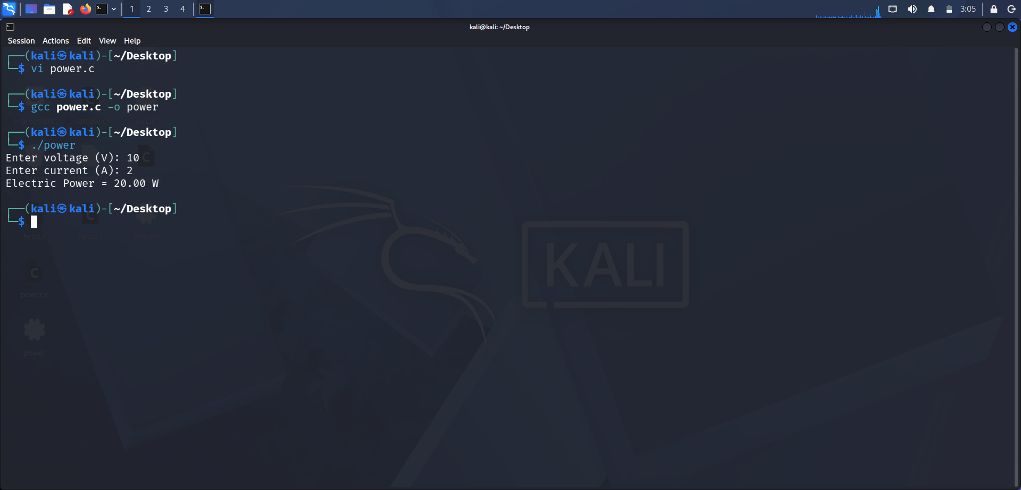
Execution / Output:
The program was successfully compiled and executed in Kali Linux.
Input:
Voltage = 10 V
Current = 2 A
Output:
Electric Power = 20.00 W

Question 3: Vertical Component of Vector
Problem Statement:
Write a C program to find the vertical component of a vector when its magnitude and angle are given.
Input:
- Magnitude of vector (A)
- Angle (θ) in degrees
Output:
Vertical component of vector (Ay)
Formula:
Ay = A × sin(θ)
Test case | Magnitude(A) | Angle (θ) | Expected Vertical  Component(Ay)
1 | 10 | 30° | 5.00
2 | 20 | 90° | 20.00
3 | 15 | 60° | 12.99

Algorithm:
- Start the program.
- Enter the magnitude of the vector (A).
- Enter the angle (θ) in degrees.
- Convert the angle from degrees to radians.
- Calculate the vertical component using the formula Ay = A × sin(θ).
- Display the vertical component (Ay).
- Stop the program.

#include <stdio.h>
#include <math.h>

int main()
{
float magnitude, angle, radians, vertical_component;

printf("Enter magnitude of vector: ");
scanf("%f", &magnitude);

printf("Enter angle in degrees: ");
scanf("%f", &angle);

radians = angle * 3.14159 / 180.0;

vertical_component = magnitude * sin(radians);

printf("Vertical Component = %.2f\n", vertical_component);

return 0;
}
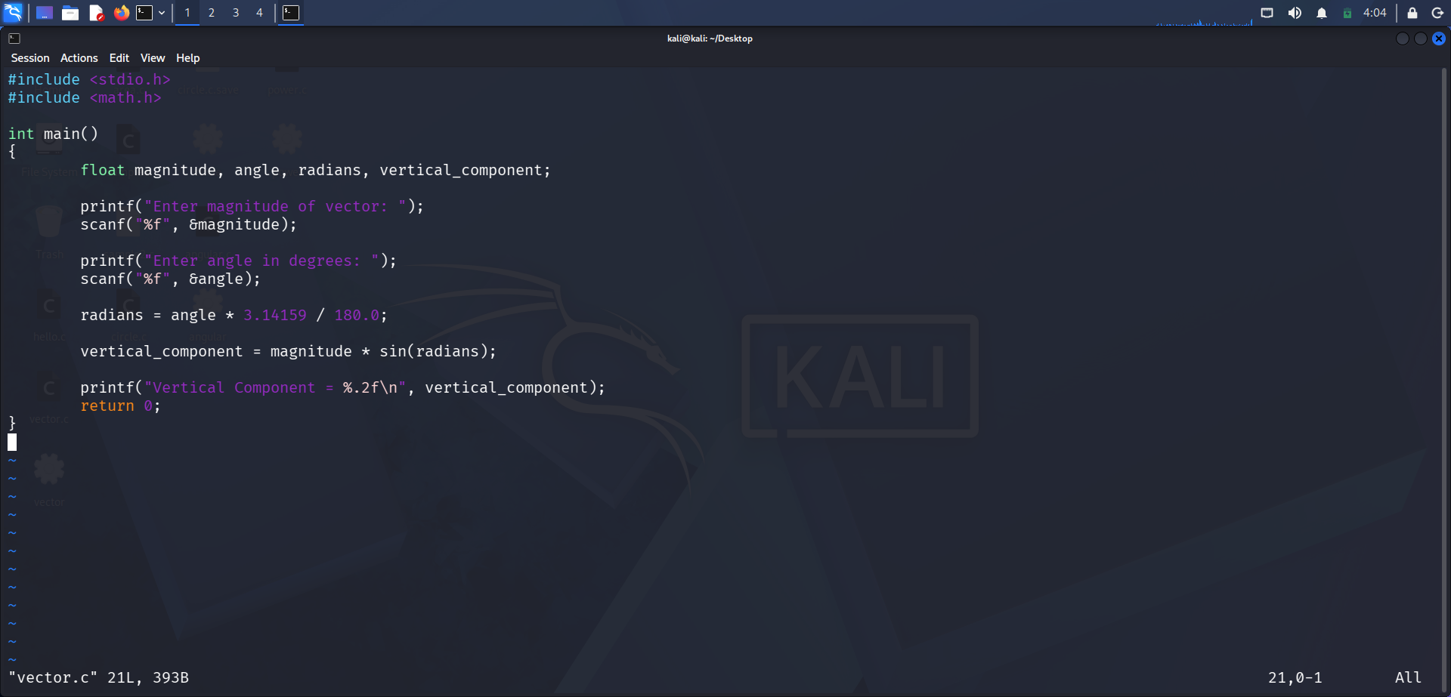

Execution / Output:
The program was successfully compiled and executed in Kali Linux.
Input:
Magnitude of Vector = 10
Angle = 30°
Output:
Vertical Component = 5.00

